SOLUTION - CODING ACTIVITY 2.2

De-structuring And Props:

import { useState } from "react";

*function* Person() {

*const* [state, setState] = useState({

    details: { name: "", residence: { city: "", country: "" }, profession: "" }

  });

*const* Details = (*props*) *=>* {

    // TODO: destructure props

*var* mylist=*props*.person

    mylist.details.name="Mardona";

    mylist.details.residence.city="Tigre"

    mylist.details.residence.country="Argentina"

    mylist.details.profession="Soccer"

    setState(mylist)

    return (

      <div style={{ margin: "1em" }}>

        <div id="name">Name: {*props*.person.details.name}</div>

        <div id="city">City: {*props*.person.details.residence.city}</div>

        <div id="country">Country: {*props*.person.details.residence.country}</div>

        <div id="profession">Profession: {*props*.person.details.profession}</div>

      </div>

    );

  };

  return <*Details* person={state}></*Details*>;

}

export default Person;

­­

SAMPLE OUTPUT

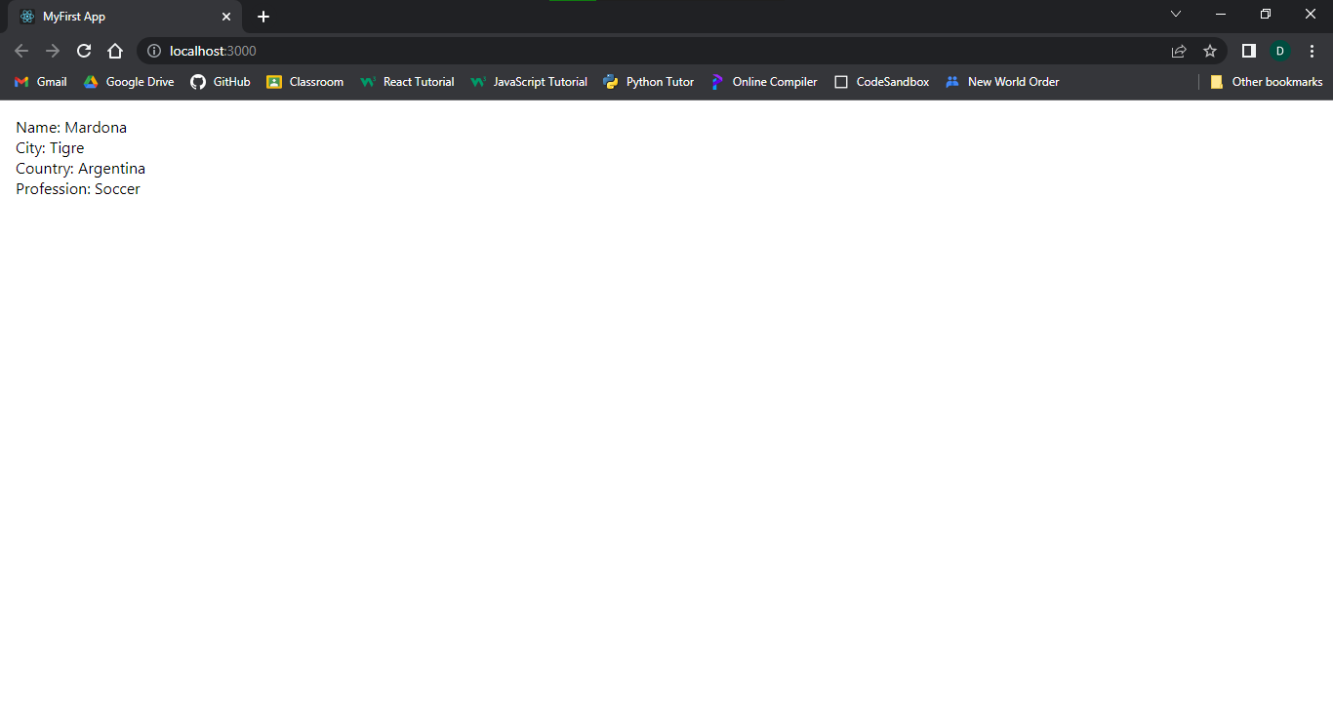

Figure 2.2.1